Ai Assistant Coding
Week:4.3
Name : A.saicharan
Ht.No: 2403A52L08
Batch:50
Task 1: Zero-Shot Prompting – Leap Year Check
Scenario
Zero-shot prompting involves giving instructions without providing examples.
Task Description
Use zero-shot prompting to instruct an AI tool to generate a Python function that:
- Accepts a year as input
- Checks whether the given year is a leap year
- Returns an appropriate result
Note: No input-output examples should be provided in the prompt.
Expected Output
- AI-generated leap year checking function
- Correct logical conditions
- Sample input and output
- Screenshot of AI-generated response (if required)
Prompt:-
Write a Python program where you need to enter an input as year and should check whether it is a leap year or non leap year. Code:- def is_leap_year(year):
if (year % 400 == 0) or (year % 4 == 0 and year % 100 != 0):
return "Leap Year"
else:
return "Not a Leap Year"
year = int(input("Enter a year: ")) result = is_leap_year(year) print(result)
Output:-
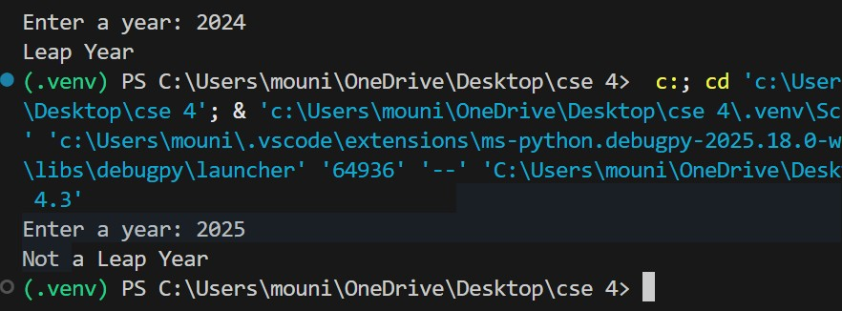
Approach:-
In this program we can learn that how zero short prompting works in leap year program without giving an example.
Task 2: One-Shot Prompting – Centimeters to Inches Conversion
Scenario
One-shot prompting guides AI using a single example.
Task Description
Use one-shot prompting by providing one input-output example to generate a Python function that:
- Converts centimeters to inches
- Uses the correct mathematical formula Example provided in prompt:
Input: 10 cm → Output: 3.94 inches
Expected Output
- Python function with correct conversion logic
- Accurate calculation
- Sample test cases and outputs.
Prompt:-
Write a Python program that converts centimeters to inches.
Example:input should be 10 cm and output should be 3.94 inches. Code:- cm = 10 inches = cm / 2.54 print(f"{inches:.2f} inches")
Output:-
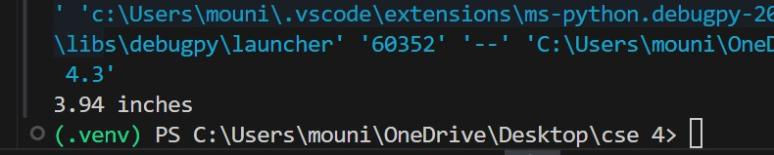
Approach:-
In this python program we can learn that how one Short promting involves by giving an example in the prompt.
Task 3: Few-Shot Prompting – Name Formatting
Scenario
Few-shot prompting improves accuracy by providing multiple examples.
Task Description
Use few-shot prompting with 2–3 examples to generate a Python function that:
- Accepts a full name as input
- Formats it as “Last, First” Example formats:
- "John Smith" → "Smith, John"
- "Anita Rao" → "Rao, Anita"
Expected Output
- Well-structured Python function
- Output strictly following example patterns
- Correct handling of names
- Sample inputs and outputs.
Prompt:-
Write a python program for accepting a full name as input and formats it as “Last, First”.Example formats: • "John Smith" → "Smith, John"
- "Anita Rao" → "Rao, Anita" Code:-
full_name = input("Enter full name: ") parts = full_name.split() first_name = parts[0] last_name = parts[-1]
formatted_name = f"{last_name}, {first_name}" print(formatted_name)
Output:-
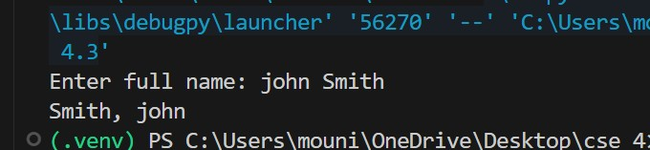
Approach:-
In this python program we can learn how one short prompt works by giving multiple examples.
Task 4: Comparative Analysis – Zero-Shot vs Few-Shot
Scenario
Different prompt strategies may produce different code quality.
Task Description.
- Use zero-shot prompting to generate a function that counts vowels in a string
- Use few-shot prompting for the same problem
- Compare both outputs based on: o Accuracy o Readability o Logical clarity
Prompt:-
Write a python program that counts vowels in a string and compare both outputs based on Accuracy,Redability and logical clarity. Code:-
text = input("Enter a string: ") vowels = "aeiouAEIOU" count = 0

for ch in text:
if ch in vowels: count += 1 print("Vowel count:", count)
Output:-
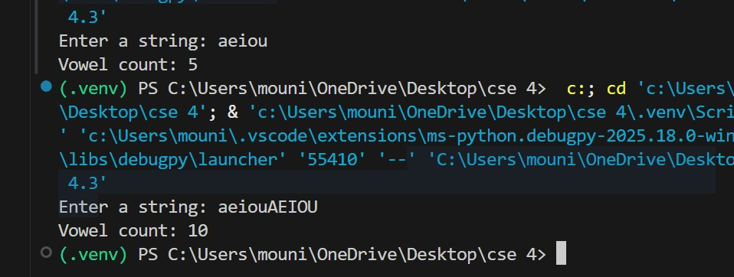
Approach:-
In this code we can know ,that how to conver vowels to string by using Zero short prompting means without giving any example.

Task 5: Few-Shot Prompting – File Handling
Scenario
File processing requires clear logical understanding.
Task Description
Use few-shot prompting to generate a Python function that:
- Reads a .txt file
- Counts the number of lines in the file
- Returns the line count
Expected Output
- Working Python file-processing function
- Correct line count
- Sample .txt input and output
- AI-assisted logic explanation
Prompt:-
Write a python program by using few short prompting which Reads a .txt file ,counts the number of lines in the file and returns the line count. Code:- def count_lines_in_file(file_path):
if __name__ == "__main__": sample_file = 'sample.txt' with open(sample_file, 'w') as f:
f.write("Hello, World!\n")
f.write("This is a sample file.\n")
f.write("It has multiple lines.\n") line_count = count_lines_in_file(sample_file) print(f"The file '{sample_file}' has {line_count} lines.") Output:-
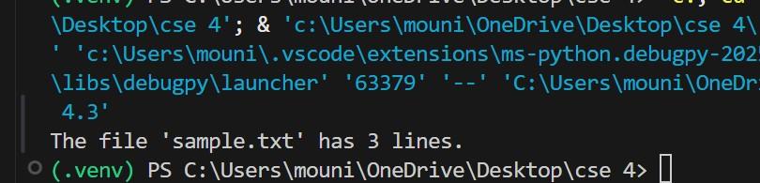
Approach:
In this code we can learn how the file is reading by using few short prompting.

